Supporting Information

Table S1. Average minimum and maximum daily temperature (°C) and dissolved oxygen (DO; mg • L⁻¹) in epilimnetic and hypolimnetic layers at Norwood and Blue Ruin alcoves from July 31 to August 7.
Norwood | Temp (℃) | DO (mg • L⁻¹)
Average minimum hypolimnion | 12.5 | 1.2
Average maximum hypolimnion | 13.6 | 8.4
Average minimum epilimnetic | 20.0 | 6.9
Average maximum epilimnetic | 25.0 | 11.3
Blue Ruin | Temp (℃) | DO (mg • L⁻¹)
Average minimum hypolimnion | 12.1 | 2.5
Average maximum hypolimnion | 13.4 | 4.8
Average minimum epilimnetic | 16.2 | 3.4
Average maximum epilimnetic | 22.7 | 9.2

Table S2. Results from linear models (Norwood and Blue Ruin) and linear mixed-effects models (all cold-water alcove sites; CWA) fit to data collected during approximate 2-hour windows corresponding to daily DO-maxima (06:00–08:00) and DO-minima (18:00–20:00). Shown are estimated slope coefficients (β), standard errors (SE), and p-values for the relationship of interest.
 |  | β | SE | p-value
Norwood | DO-maxima | 0.264 | 0.007 | <0.001
 | DO-minima | 0.856 | 0.008 | <0.001
Blue Ruin | DO-maxima | 0.563 | 0.013 | <0.001
 | DO-minima | 0.306 | 0.011 | <0.001
All CWA | DO-maxima | 0.325 | 0.009 | <0.001
 | DO-minima | 0.642 | 0.008 | <0.001

a
b
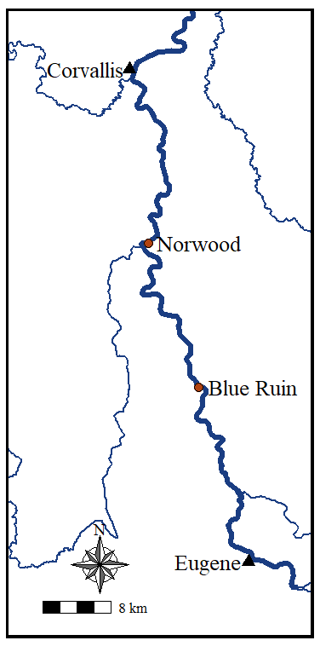
Figure S1a. Map of surveyed cold-water alcoves along the Upper Willamette River. Red points indicate cold-water alcove locations and triangles mark the location of major urban areas. b. Figure of Blue Ruin cold-water alcove with logger array (numbered triangles) and net pen (black points) locations.

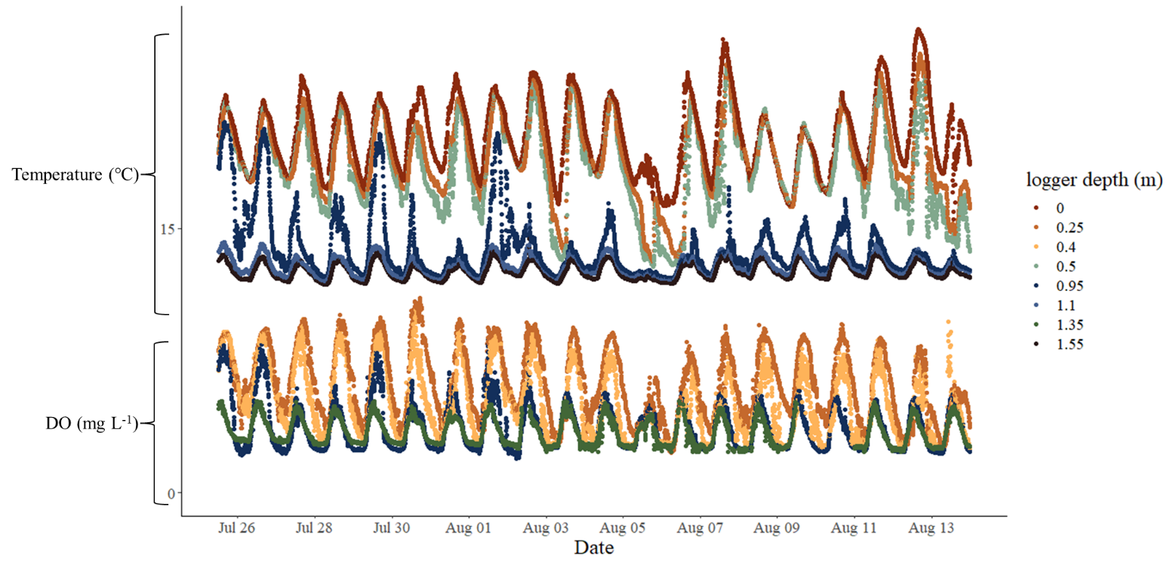
Figure S2. Temperature and dissolved oxygen recorded at the Blue Ruin cold-water alcove site-4 net pen logger array.

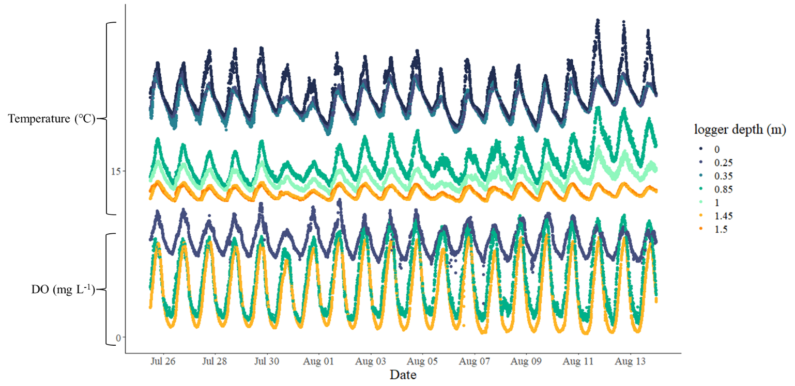

Figure S3. Temperature and dissolved oxygen recorded at the Norwood cold-water alcove net pen logger array.

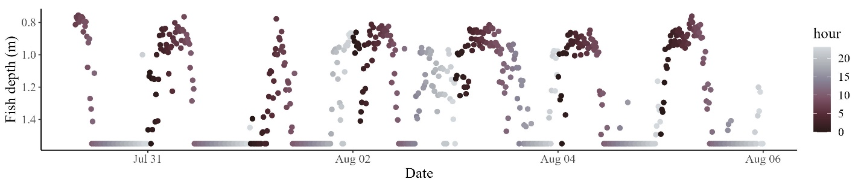
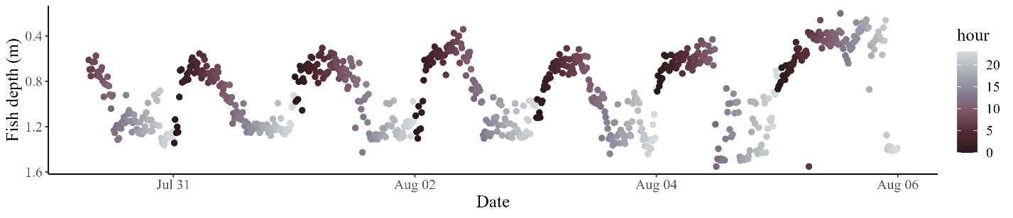
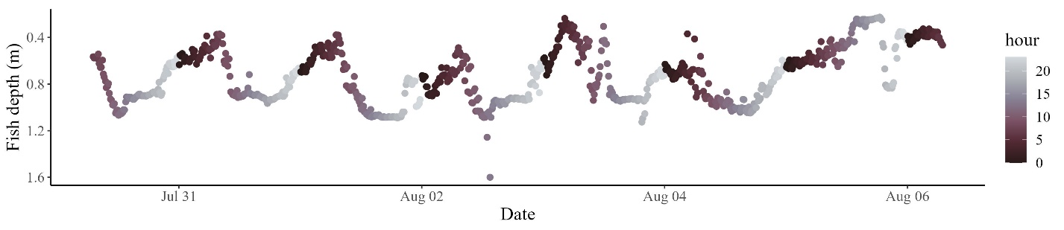
Figure S4. Depth plots of 3-individual tagged fish from the iButton netpen study, fish display individual and intra-individual level variation in movement, however all display fine scale diel vertical movement patterns.

